OCCUPATIONAL CHALLENGES FACED BY SPECIAL SCHOOL TEACHERS
-A STUDY IN TRIVANDRUM DISTRICT
A dissertation submitted in partial fulfillment of the requirements for the award of degree of

MASTERS IN SOCIOLOGY
2016-2018

Submitted By
ACHSAH GEORGE
Exam Code: 56013404
Candidate Code: 560 16 115 001
Subject Code: 560

UNDER THE GUIDANCE OF
Prasad R.


LOYOLA COLLEGE OF SOCIAL SCIENCES, TRIVANDRUM-695017, KERALA
UNIVERSITY OF KERALA

DECLARATION
I, ACHSAH GEORGE do hereby declare that the Dissertation titled “OOCUPATIONAL CHALLENGES FACED BY SPECIAL SCHOOL TEACHERS -A STUDY IN TRIVANDRUM DISTRICT” is based on the original work carried out by me and submitted to the University of Kerala during the year 2016-2018 towards partial fulfillment of the requirements for the Master of Arts Degree Examination in Sociology. It has not been submitted for the award of any degree, diploma, fellowship or other similar title of recognition before any University or anywhere else.

Thiruvananthapuram Ms. Achsah george

CERTIFICATE OF APPROVAL
This is to certify that the work embodied in this dissertation entitled “OCCUPATIONAL CHALLENGS FACED BY SPECIAL SCHOOL TECHERS –A STUDY IN TRIVANDRUM DISTRICT ” has been carried out by Achsah George of Fourth semester, Master of Sociology under my supervision and guidance, that is hereby approved for submission.

Mr. Prasad R.
Guest Faculty,
Department of Sociology,
Loyola College of social sciences, Thiruvananthapuram.

Recommended for forwarding to the University of Kerala

Dr. Nisha Jolly Nelson
Head of the department of Sociology,
Loyola College of social sciences Thiruvananthapuram.

Recommended for forwarding to the University of Kerala

Dr. Saji P. Jacob
Principal,
Loyola College of social science Thiruvananthapuram.

ACKNOWLEDGEMENT
At the outset, I thank God Almighty for the wisdom he bestowed upon me, the peace of mind, the strength and good health to finish this project.
I would like to extend my sincere and heartfelt obligation towards the persons who have helped me in this endeavour. Without their active support, guidance and encouragement, I would not have made headway in this project.
I am indebted to my research guideMr Prasad R, Guest Faculty, Department of Sociology, Loyola College of Social Sciences, Trivandrum, for his guidance and support without which this work would not have been completed. I express my sincere gratitude towards him for his timely guidance, useful comments and constant encouragement.
I extend my wholehearted gratitude to Dr. Saji P. Jacob, Principal, Loyola College of Social Sciences and Dr. Nisha Jolly Nelson, Head of the department of Sociology, Loyola College of Social Sciences, Ms. Lini Jolly and Ms.Terese Mary Chacko, Faculty, Department of Sociology, Loyola College of Social Sciences, who have helped me immensely, and for their support, assistance and guidance whenever required during several junctures of my research.
I thank Dr. Sunil Kumar P, Librarian, Loyola College of Social Sciences and other library staff for providing me right access to correct and authentic information and knowledge without which the project would not have been as informative as it is now.
I also thank the Respondentswho have cooperated with me and also trusted me to share their personal detail with me, without which this project would be incomplete.
I am thankful to my Family for being my support wall throughout this project. I also extend my sincere gratitude to my Friends who spared their precious time and energy to help take this project to fruition.

Achsah George

CONTENT
Chapter |  | Page No.
 | LIST OF TABLES
 | LIST OF GRAPHS
I | INTRODUCTION  1.1 Background of the study  1.2 Statement of the problem  1.3 Significance of the study | 9-14  14  15
II | LITERATURE REVIEW | 16-27
III | METHODOLOGY | 28
 | 3.1 Introduction  3.2 General Research objectives  3.3 Specific Research Objectives  3.4 Conceptual definition  3.5 Operational definition  3.6 Research design  3.7 Tool of data collection  3.8 unit  3.9 Area  3.10 Sample size  3.11 Sampling technique  3.2 Limitation of the Study | 29  29  29  29  30  30  30  30  30  30  30  30
IV | DATA PRESENTATION & ANALYSIS | 32 -48
V | FINDING,CONCLUSION &SUGGESTIONS | 49
 | 5.1 Introduction  5.2 Socio demographic profile  5.3 Working condition  5.4 Support system  5.5 Stress level  5.6 Conclusion  5.6 Suggestions | 50  50  51  51  52  53  54
 | BIBLIOGRAPHY | 55
 | APPENDIX | 56-61

LIST OF GRAPHS
Figure | Topic |  | Page No.
4.1 | Age group of the respondents |  | 32
4.2 | Education qualification of the respondents |  | 33
4.3 | Community of the respondents |  | 33
4.4 | Type of house of the respondents |  | 34
4.5 | Total income of the respodents |  | 35
4.6 | Years of experience of the respondents |  | 36
4.7 | Salary of the respondents |  | 36
4.8 | Financial liabilities of the respondents |  | 37
4.9 | Working hours of the respondents |  | 37
4.10 | Class size of the respondent |  | 38
4.11 | Infrastructure facilities of the respondents |  | 39
4.12 | Injuries from students faced by the respondents |  | 39
4.13 | Leave conditions for the respondents |  | 40
4.14 | Challenges during teaching |  | 40
4.15 | Thought for leaving job of the respondents |  | 41
4.16 | Support from family of the respondents |  | 41
4.17 | Support from parents of student for the respondents |  | 42
4.18 | Support during work related problems of the respondents |  | 42
4.19 | Support through appreciation and encourage for the respondents |  | 43
4.20 | Support when sharing problems of the respondents |  | 43
4.21 |  | Support through advices and guidance | 44
4.22 |  | Stress due to more responsibility of the respondents | 44
4.23 |  | Stress due to conflicting demands from students, parents ,administrators and teachers of the respondents | 45
4.24 |  | Stress due to work with insufficient resources by the respondents | 45
4.25 |  | Administrative support by asking the opinion which directly affect the respondents | 46
4.26 |  | Stress due to when work become routine and boring of the respondents | 46
4.27 |  | Stress due to school activities outside normal working hours of the respondents | 47
4.28 |  | Stress due to meet the needs of fellow faculty of the respondents | 47
4.29 |  | Stress due to extra effort to instruct students | 48

CHAPTER 1
INTRODUCTION

1.1 BACKGROUND OF THE STUDY

Since the time immemorial, education has been playing key role in making human beings and shaping the civilizations. Our country has a huge resource of the ideas and knowledge to share with the world. Since the ancient civilizations in our country, education has immensely created a profound impact in shaping of the behaviour of the individuals as well as making the civilizations. The teaching profession is one of the helping professions in which practitioners are normally committed to giving their best for the welfare of those entrusted in their care. While the commitment is laudable, the consequences can be detrimental when the job demands overshadow the individual's coping resources, as well as the job rewards; thus leaving the practitioner feeling unhappy and unable to perform well (Hayward, 1991). The role of the teacher in the educational process is pivotal because, of all the human factors in the educational process, the teachers occupy the key position and it is only through their key role the whole education system is regulated and ultimate goal is achieved.

A special school teacher is someone who works with children and youths who have a variety of disabilities .children with disabilities means children or student who require special education because of :autism ;communication disorders ;deaf; blindness ;emotional disturbance ;hearing impairments including deafness ,intellectual disability ,orthopaedic impairments other health impairments .children with special needs require unique instruction by specially trained professionals to help them achieve their highest potential and strive to progress beyond their limitations . A learning disability student have poor auditory memory both short term and long term ,a long tolerance level and high frustration level, poor or weak self esteem easily distractible ,spontaneous in expression ;often cannot control emotions, easily confused ,verbally demanding ,they have difficulty in working with others in small or large group of setting etc. So a special school teacher should have more time and patience to deal with them and also the student require specialized instructional strategies in a structured environment and that support and enhances their learning potential.
However, during more recent times, systematic efforts took place in providing educational and vocational opportunities to individuals with disabilities in India. Starting with Christian missionaries in the 1880s, the charity model became part of the special schools they established (Alur, 2002). For instance, formal educational institutions were established for the blind in 1887, for the deaf in 1888, and for mentally deficient in 1934 (Misra, 2000).After these early establishments in the late 19th century or early 20th century, a growth was seen in the establishment of these institutions in the later half of the 20th century. After independence from Great Britain in 1947, there was a systematic development of special education in India that saw the establishment of 81 schools between 1960 and 1975. By 1979, the number of special education centers was 150. With the establishment of the National Institute for the Mentally Handicapped (NIMH) in 1986 and others soon after, the availability of trained personnel and suitable models of service made the growth of special schools for children with disabilities very significant. According to a UNICEF Report on the Status of Disability in India(2000), there were around 30 million children that had some form of disability. Another report, the sixth All-India Educational Survey reported that of India’s 2,000 million school aged children (6_14 years), 20 million require special needs education (Rehabilitation Council of India (RCI), 2000).
While teacher preparation in special education has witnessed a major change in the last two decades in India, it is still lagging behind to meet the demands of increased number of teachers in the country. In order to meet with the demands of special education teachers in the country, the Govt had set up national institutes on various disabilities in the 1980s (e.g., NIMH, National Institute for the Visually Handicapped (NIVH)). These national institutes and their regional centres in various parts of the country became instrumental in offering bachelor’s degree or diploma courses in special education. For example, the NIMH started offering a Bachelor’s degree course in Mental Retardation (BMR) as early as 1987. Other national institutes started such initiatives as well. The range of courses offered by these institutions and other universities grew rapidly over a period of time. Currently the course offerings include certificate courses that may last for three months to doctoral degree in special education and allied fields. In addition to aiding with the manpower development in the country, these national institutes played a key role in conducting research in special education and developing pedagogy unique to India. The GoI also formed an autonomous body, RCI in 1993 by passing RCI Act in 1992 to regulate the special education and rehabilitation course offered by government agencies and NGOs. RCI has been instrumental in ensuring program quality offered by the teacher training institutions. It regulates and monitors services rendered to persons with disabilities and standardizes syllabi. It also maintains a Central Rehabilitation Register of all qualified professionals and personnel working in the field of Rehabilitation and Special Education in India.educational services.
Enabling legislation:rehabilitation council of india act(RCI-1992) :The PAO was strengthened by the enactment of the RCI Act,1992.experience showed that there was no mechanism in the country to standardize and monitor the training of special educators and other rehabilitation professionals in the country .therefore,in 1992,parliament of India enacted the RCI Act ,subsequently amended in 2000,to establish a statutory mechanism for monitoring and standardizing courses for the training of 16 categories of professionals required in the field of special education and rehabilitation of persons with disability .training of special educators and resource teachers that can offer support services to children with special needs in regular schools in the responsibility of RCI.
There are lot of occupational challenges or problems that are faced by special school teachers such as lack of teacher training, task analysis, support services ,lack of infrastructure facilities ,time constraints ,lower salary, stress and burnout etc . Stress is defined as the experience by a teacher of unpleasant emotions, such as frustration, anxiety , anger and depression, resulting from aspects of his/her work as a teacher (Kyriacou, 1987). A stressor is an experience or situation within or outside the individual, which elicits a stress response. Variables such as social support, personality, and self-efficacy have the potential to impact and possibly reduce stress reactivity and strains (Lazarus, 1966; 1999). In regards to social supports, the extant literature affirms that there is a connection between teacher stress and social supports. For instance, Griffith, Steptoe, and Cropely (1999) reported that teachers with high job stress have low social support at work. Richards (2012) found that the most common method of coping with teacher stress is relying on the relationships of friends and family. Teachers are working hard and are trying their best to fulfil the entire dimension in terms of bringing all around development of the child.
There are certain elements and conditions that are taken into accord for teaching :Authorities and teachers should recognize the importance of the participation of teachers ,through their organizations and in other ways ,in steps designed to improve the quality of the education service, in educational research , and in the development and dissemination of new improved methods,Class size should be such as to permit the teacher to give the pupils individual attention .From time to time provision may be made . for small group or even individual instruction forsuch purposes as remedial work , and on occasion for large group instruction employing audio-visual aids; With a view to enabling teachers to concentrate on their professional tasks, schools should be provided with ancillary staff to perform nonteaching duties, Authorities should provide teachers and pupils with modern aids to teach i n g. Such aids should not be regarded as a substitute for the teacher but as a means of improving the quality of teaching and extending to a larger number of pupils the benefits of education. The hours teachers are required to work per day and per week should be established in consultation with teachers' organizations. In fixing hours of teaching account should be taken of all factors which are relevant to the teacher's workload, Teachers should be provided time necessary for taking part in-service training programmes . Women teachers with children should be encouraged to remain in the service by such measures as enabling them, at their request, to take additional unpaid leave of up to one year after childbirth without loss of employment , all rights resulting from employment being fully safeguarded, School buildings should be safe and attractive in overall design and functional in layout; they should lend themselves to effective teaching, and to use for extra - curricular activities and, especially in rural areas , as a community centre ;they should be constructed in accordance with established sanitary standards and with a view to durability, adapt ability and easy, economic maintenance. Amongst the various factors which affect the status of teachers, particular importance should be attached to salary, seeing that in present world conditions other factors, such as the standing or regard accorded them and the level of appreciation of the importance of their function, are largely dependent, as m other comparable professions, on the economic position in which they are placed. Sickness benefit should be granted through out any period of incapacity for work involving suspension of earnings. Teachers rs should be protected against the consequences of injuries suffered not only during teaching at school but also when engaged in school activities away from the school premises or grounds . All teachers should enjoy a right to adequate annual vacation with full pay. Teachers should be entitled to sick leave with pay,In determining the period during which full or partial pay shall be payabl e, account should ;be taken of cases in which it is necessary for teachers s to be isolated from pupils for long periods . Effect should be given to the standards laid down by the Intern ational Labour Organisation in the field of maternity protection , and in particular the Maternity Protection Convention ,1919 , and the Materrnity Protection Convention( Revised ) , 1952 .( Adopted on 5 October 1966 by the Special Intergovernmental
Conference on the Status of Teachers, convened by UNESCO,
Paris, in cooperation with the ILO)
The specific work environment for teachers has also been found to be stressful. Jarvis (2002)has noted that long hours and heavy workloads were issues of special concern to teachers in England where Moore (2000) also noted that there were stressful problems in scheduling, allocation of time for various classes and activities and the physical layout of the school. In his seminal work in Zimbabwe, Nhundu (1999) found that major sources of stress for teaching professionals included high workload, lack of resources, overcrowded classrooms and perceived lack of government support.

1.2 STATEMENT OF THE PROBLEM
A special education teacher is someone who works with children and youths who have a variety of disabilities . Children with disabilities means children or student who require special education because of :autism; communication disorders; deaf; blindness ; emotional disturbance; hearing impairments including deafness , intellectual disability , orthopaedic impairments ,other health impairments. Children with special needs require unique instruction by specially trained professionals to help them achieve their highest potential and strive to progress beyond their limitations. Dean (2006): Special education teachers when compared to other profession have a higher rate of burnout. It is estimated that 75% of those who teach special needs students will leave their job within 10 years of starting . While a special education teacher may start their career with the intension of helping disabled students become productive members of society , they face several challenges that make the task extremely difficult. A learning disability student have poor auditory memory both short term and long term ,a low tolerance level and high frustration level , poor or weak self-esteem , easily distractible ,spontaneous in expression ;often cannot control emotions , easily confused , verbally demanding ,they have difficulty in working with others in small or large group of setting , etc.So a special school teacher should have more time and patience to deal with them and also the student require specialized instructional strategies in a structured environment and that support and enhances their learning potential.
The present study looks into the occupational challenges faced by special school teachers .the study focus on their socio-economic status, working conditions ( working hours , infrastructural facilities ,teaching aid etc) , support system (from their parents or spouses , government, authorities ), and support from student parents . The stress level of special school teachers is also examined . The present study focuses into the occupational challenges faced by special school.

1.3 SIGNIFICANCE OF THE STUDY
In the present scenario, a lot of researches are being carried out about the problems and challenges faced by differently able children .The State capital witnessed the poignant scene of hundreds of mentally challenged children writing and painting their dreams and woes on a white cloth stretching and almost all around the Secretariat .Special school teachers and children organized protest for getting their rights.(The Hindu 1-11-2017)All students have the right to education according to Indian constitution but now a days these right is refusing for special school students. State give an order for 33 schools in which have more than 100 students is accredited as aided school but it is not yet implemented. In Kerala there are 284 special schools and only one school is directly undertaken by government. The teachers and other staffs are only getting less than 5000 as salary and it an injustice towards them.(Malayala Manorama 15-04-2018) Care takers are often been given less preference, their needs and concerns are often been neglected, which is an issue to be considered. So the study addressing the occupational challenges faced by special school teachers in Kerala is relevant in the present scenario.

CHAPTER 2
REVIEW OF LITERATURE

REVIEW OF LITERATURE
Review of literature is elemental that constitute a significant part of any research that is been done. Review of literature helps the researcher to get a deep and broader insight on the particular area that is being researched. It gives both the conceptual framework as well as the empirical evidence for the research. Through a comprehensive study of existing literatures on the topic, the scope of the current research becomes valid and reliable. It helps the researcher to find the gaps in the existing studies on the topic, and enables the ongoing study to fill those gaps. Review of literature provides the current research evidence based data and effective models of intervention, which would further augment to the rationale and impacts of the ongoing study.In this review of literature ,studies which have been done on the area of problems or challenges faced by special school teachers are studied in a pervasive way.the researcher has done the rview of literature based on some of the variables being measured in the current study.it includes both published books and research articles to get a broader conceptual understanding as well as empirical studies in the are of special education.
Each special education teacher must be prepared to teach students all along this broad continuum of difficulties that affect learning including ,but not limited to,learning disabilities sensory impairments ,cognitive delays ,emotional and behavioural problems, motor and mobility –related disabilities and autism spectrum disorder .each eligible student has a special education teacher who supports his or her learning ,0versees the execution of the educational plan and coordinates services (IDEA 2004).The National Board for professional Teaching Standards (NBPTS) and the Council for exceptional children (CEC) have created similar descriptions of the complex roles fulfilled by special education teachers ,including utilizing professionally recognized best practices for instruction ,management and assessment, knowing each individual student’s strengths and challenges ,advocating for students and collaborating with families and other education professionals involved with students’ instructional teams (CEC,2004;NBPTS,2001)Special education teachers continue to complete the complex job responsibilities required to encourage the academic achievement of students with special needs .
Burnout is a major problem in the field of special education (Gersten et al ,2001;Stempien &Loeb ,2002).burned out ,emotionally exhausted special education teachers are considerably less effective in their work compared with those who are less stressed and exhausted (Brownnell et al.1997;gerstenet al,2001).Withdrawal from the job and failure to achieve goals are also likely to occur among teachers who experience burnout (Gersten et al ,2001).Maslah and Jackson (1981)claimed the burnout is made up of three primary components : emotional exhaustion ,depersonalization and a reduced sense of personal accomplishment .
Job stress is a part of any teaching position,special education teachers must deal with situations that are inherently less controllable tha those faced by their general teachers education counterparts (Skaalvik and Skaalvik (2007)purport that :The stressors (experienced by special education teachers )may include students with behavioural problems ,problems in the parent –teacher relationship ,conflict with colleagues or having to organize teaching in new ways as a consequence of working in teams or because of school reforms(p.613).
World studies
Meeting the daily learning and behavioural needs of students makes teaching a stressful job. Not every type of stress that associated with teaching is negative .stress that able to reduce teachers motivation can have deleterious effects such as alienation from the workplace ,absenteeism and attrition. in fact when special school teachers are severely stressed by the unmanageability of their workload, they are more likely to leave the special education classroom (Miller, Brown,& Smith, 1995).the ability to successfully manage stresses to teaching is critical if special school teachers are to survive and thrive in the classroom. despite the current trend toward school-based decision making ,a lot of schools remain to implement bureaucratic organization where teachers have little control over major decision in their environment and frequently work in isolation (Skrtic, 1991).further , with increasing demands to be accountable, teachers ‘work is becoming more intense ,leaving many teachers feeling emotionally exhausted(Hargreaves, 1994).thus ,in school bureaucracies, teachers may become stressed by role overloaded and lack of autonomy.
In 2001 ,Malaysian ministry of education had introduced the education development 2001-2010 .among the motives of this scheme is to develop individual potential entirely in order to produce mankind who are emotional ,intellectual ,spiritual and physical balanced ,consistent with the National Education Philosophy ;to promote creativity and innovation among students to enhance knowledge ,science and technology culture; to increase lifelong learning; to prepare an efficient and effective education system which can achieve international standard ;to become the educational centre that can provide excellent education and to increase Malaysia education ‘s prestige in international level (educational department 2001-2010,2001).in the realization of this motive ,Malaysia has put a severe expectation in school teachers they are perceived as the architect, designer,and saver of the future of our children who are responsible to educate them .however ,we have to realize that teaching is not an easy job as what other people think and perceive .In fact ,Claxton (1989) indicated that teaching is an occupation which is always demanding and changing. Teachers are required to equipped themselves with various quality, knowledge and skills so that they can become ascetic model that should have ideal mannerism ,become a role model to students ,never make a mistake ans also mange to give an effective teaching (Peter Songan and Narawi, 2002).this stereotype and severe expectation in teachers is a source of teacher stress. A study conducted by school of educational studies university saints Malaysia ,11800, Penang, Malaysia about stress among special education teachers in Malaysia they investigated that there are five major factors that contribute to stress among special school teachers in Penang .Their study shown that the overall stress level among teachers is moderate and also identified that pupil misbehaviour as the main source of teacher stress among special education teachers ,followed by workload ,time and resources difficulties ,recognition ,and interpersonal relationship. These result are consistent with the findings of Ramli (2003) ,pratt (1978), Abdul Rahim(2002) and Mazlan(2002) which indicated that pupil misbehaviour is the main cause of teacher’s stress.
A study about special education teachers network results shows that special school teachers’ isolation may frequently result from the physical environments of schools; SE teachers often have remote work spaces (Hargreaves, 1992, 224–225). Both McLeod’s and Hargreaves’ reports are supported by the present data; event sampling indicated that the SE teacher had problems with the work space, and his role as outsider was especially in evidence when one considers differences in classroom teachers’ and SE teachers’ work descriptions. In this regard, it is relevant that, unlike classroom teachers, SE teachers work in numerous environments with changing student groups and also SE teachers’ challenges encountered during the semester was related to clarifying his work description and professional identity.SE teacher’s position as a central broker (Nardi et al., 2000) in knowledge-sharing activities made it possible for him, presumably, to guide the flow of relevant expert and knowledge resources to his workplace community by relying on diverse contacts outside his immediate social network. SE teacher with a broad professional scope may be characterized as a networked expert who is a collaborator dependent on his work community; he identifies resources from the environment according to the evolving needs of the student and appears to rely on hybridized expertise concerning individual students, school practices, pedagogy of special education, administration, psychology, health care, and social work.
The conceptual and practical changes that have taken place during the past four decades relating to students with special needs have in turn changed the role of special education teachers until it is almost unrecognizable (Carpenter&Dyal, 2007;Purcell,Horn, & Palmer,2007)Special education teachers today work in broad and open frameworks and in complex organizational systems that require they possess wide-ranging knowledge of the discipline; have strategies to deal with many fields of responsibility; and possess expertise, leadership qualities, and the ability to lead the educational staff (Jorgensen, Shuh, & Nisbet, 2006). Special education teachers must supply an ever-increasing number of educational services to an assortment of students with and without special needs (Hoover & Patton, 2008), guide general teachers in developing teaching activities adapted to these students, and take part in regular daily teaching tasks (Eisenman, Pleet, Wandry, & McGinley, 2011). Effective handling of these multitude of duties requires teachers have a strong sense of efficacy (Kiran, Yousuf, Siddique, & Ehsan, 2014).Wigle & Wilcox (2003) examined perceived self-efficacy in fulfilling educational roles among special education teachers with diverse experiences. The study covered five US states that follow the standards defined in 1997 by the CEC as criteria for measuring perceived self-efficacy. The teachers reported strongest self-efficacy regarding their ability to carry out traditional roles – such as understanding and interpreting information about special needs students – which decreased gradually as they were required to handle newer roles, like developing relations with out-of-school agencies. During the last 40 years, special education has undergone radical change. Until the 1970s, the categorical approach ruled, which placed the learning and behavioral needs of special needs students on a continuum of severity, and saw special education teaching a means to reach developmental milestones according to accepted norms. During the 1980s, with the introduction of inclusion of students with special needs in general education, this was replaced by a non-categorical approach that questioned the relevance of categorization to planning and carrying out effective teaching and produced direct, explicit, and systematic teaching focused on the functional progress of the individual. During the 1990s, understanding that the main mission of special education is to prepare students with special needs for full membership in the community by guaranteeing access to the entire range of educational and social opportunities offered by the school, the role of special education teachers again underwent change (Ainscow, 2007; Winzer,2007). They began working in a large variety of teaching situations, moving from self-contained academic classes to general classes in regular schools. In these situations, their tasks were broadened and measures of success not present in the past were added, making them more complex and demanding. Special education teachers are today required to attain more ambitious goals responding to every-increasing cultural differences, languages, learning styles, disabilities, and capabilities; to possess a richer repertoire of strategies; and to teach a wide variety of information content to various age groups. They must cooperate with a diverse group of professionals (Eisenman et al., 2011; Scruggs, Mastropieri, & McDuffie, 2007; Thousand, Nevin, & Villa, 2007), provide advisory services to general teachers (Robinson & Carrington, 2002), and develop the assistance they need (Idol, 2006). Today they must work in full cooperation with the families of students with special needs and understand and respect their senior position in the process (Dunlap, Newton, Fox, Benito, & Vaughn, 2001).In reality, special education teachers today are expected to perform many functions that are not purely teaching (Wasburn-Moses, Leah, 2005), including providing leadership in the school in implementing inclusion (York-Barr, Sommerness, Duke, & Ghere, 2005). As leaders, they must have a command of numerous organizational approaches (Bowman, 2004; Katzenmeyer & Moller, 2009) and incorporate an innovative educational approach in the school concerning social justice, human rights, and labelling (Shepherd & Hasazi, 2007; Dunlap, et al., 2001).
These requirements and responsibilities are based on standards updated in 2013 by the Council of Exceptional Children (CEC). One section of the standards is devoted exclusively to beginning teachers: CEC Initial Level Special Educator Preparation Standards (NCATE approved November 2012). Another is devoted to experienced teachers: CEC Special Education Specialist Advanced Preparation Standards (NCATE approved November 2012). Both standards demand teachers rise to difficult challenges. Hartmann (2012) suggested that effective responses by special education teachers to such challenges in their work is tied to high self-efficacy, which has been described as individuals’ belief in their ability to carry out a particular behaviour well, leading to the desired result. This belief influences human behaviour in the sense that it determines how individuals organize the actions necessary to control unexpected situations and how they invest the necessary effort in their tasks, and the extent of their ability to persevere in their undertakings (Bandura, 1977). Teachers’ self-efficacy is described as their subjective perception of their ability to carry out tasks related to teaching and educating students, as well as those associated with the organization in general. It is also related to having good personal relationships, integrating into the organization, and successfully coping with threatening situations – both concerning the school administration and colleagues, and the classroom (Friedman & Kas, 2002).Wigle & Wilcox (2003) examined perceived self-efficacy among special education teachers with one to three years’ experience regarding their ability to perform their roles. Their research was carried out in five US states that use the standards set by the CEC in 1997 as measures of self-efficacy. The teachers reported strongest levels of self-efficacy in performing traditional roles – such as understanding and interpreting information about special needs students – which weakened gradually as the roles required they cope more with challenges presented by the newer components, such as developing relations with out-of-school agencies.
A study conducted by Levinsky college of education about beginning special education teachers in Israel :perceived self -efficacy results shows that a higher percentage of respondents had strong self-efficacy with regard to specific one-dimensional topics that represent the traditional core of special education and the knowledge base acquired during years of teacher training. These are issues that may involve social desirability and the conventional image of the special education teacher who welcomes human diversity, is familiar with the law and policies, has an ethical approach to the job, and is highly competent to work in extreme human conditions. A lower percentage of the respondents showed high levels of self-efficacy regarding coping with multidimensional issues that are complex and require innovation in the work of the teacher, as well as collaboration and professional maturity. They include the need for teachers to construct their identity within the professional community, develop within its framework, and work for its advancement and also most of the beginning teachers perceived that their ability to successfully cope with extreme behaviour of an individual student represented the main component of their self-efficacy. Sense of efficacy was associated with a dialectic process that began with encounters with extreme behaviour; continued with the teachers' struggle to remedy the situation, assisted by their personal intuition and resources; and ended in a radical change in the situation accompanied by a very high sense of efficacy. Special education teachers felt they were highly competent in understanding, accepting, and respecting family diversity; understanding the limitations of the individuals and their families; and taking into account the family when preparing the curriculum. In contrast, the lowest percentage of participants in the entire questionnaire considered themselves highly competent in involving the parents of the students with special needs in all aspects of education and the study also point out that perceived self-efficacy among beginning teachers is mainly related to sense of power: the power to act in extreme crises and transform crises that seem impossible to overcome into success stories; to do the “unbelievable”; to act alone and succeed where others have failed thanks to personal traits such as “perseverance,” “stubbornness,” and “motivation,” and through “struggle” and personal war, and “a connection with the language of psycho-therapy”; the power to take total responsibility over extreme cases and make them a life mission for the teacher; to influence others, change the reality of life, and even facilitate life. Strong perceived self-efficacy is also associated with the power to exercise self-control, to defend the weak, and to change perceptions in the environment – those of peers, professional personnel, and even parents – towards the student, and the power to instruct and guide teachers and parents.
A study conducted in turkey about special education teachers perception about students with autism poinout that According to the Turkish Ministry of Education, there are currently about 500,000 people with ASD and 100,000 are children under the age of 14. This means that one in 80 children in Turkey is diagnosed with ASD. Moreover, these numbers are increasing by approximately 5,000 per year. In response to the growing numbers of students with ASD, the Educational Centres for Children with Autism (OCEMs) were established in 1999 by the Turkish Ministry of Education as part of the Education Project for Students with Autism. Teachers’ perceptions of students with ASD are important for many reasons, including a teacher’s perception may positively or negatively influence their own expectations for students, and in turn, influence students’ success both academically and socially (Silverman, 2007). Teachers who have negative perceptions of students with autism may negatively impact their students. It is likely that there is a difference in perceptions between general education teachers and special education teachers due to the varied training and experiences of teachers. Special education teachers in Turkey, especially those who graduated from special education programs received more specialized training about the learning characteristics, instructional needs, behaviour challenges, and evidenced based practices for students with ASD during their education program. This more specialized and in-depth training likely influences teachers’ perceptions in a positive fashion because they have the knowledge, background, and specialized training to feel confident and prepared to teach students with ASD. Providing specialized training to pre-service teachers and practicing teachers warrants more attention. Specifically, education training programs should focus on providing teachers more information related to students with ASD in three areas: (a) learning characteristics, (b) behavioural characteristics, and (c) evidence-based practices and also find out that what works for one student may not work for another, and students with ASD have their own individual personalities that we need to take into consideration (Marks, et al., 2003). However, there are learning characteristics of student with ASD that teachers should know and , there are also behavioural characteristics of students with ASD. Individuals with ASD may have challenging behaviours, such as aggression, self-injurious behaviours, and/or tantrums. Teacher should understand that students with ASD have their unique behavioural characteristics. Teachers need to look below the surface to identify the message a student is trying to convey (Alberta Learning, 2003).
Another essential aspect for teachers to develop expertise is with the evidence-based practices for students with ASD highlighted in the literature base. There are many evidence-based practices with demonstrated effectiveness through high quality scientific research such as functional behaviour assessment (Blair, Lee, Cho, & Dunlap, 2011; Kodak, Fisher, Clements, Paden, & Dickes, 2011), functional communication training (Gibson, Pennington, Stenhoff, & Hopper, 2010; Kuhn, Hardesty, & Sweeney, 2009), prompting (Ingvarsson, & Hollobaugh, 2011; Ostryn, C., & Wolfe, P. S., 2011; Thomas, Lafasakis, & Sturmey, 2010), video modeling (e.g., Plavnick, MacFarland, & Ferreri, 2015; Yakubova, Hughes, & Hornberger, 2015), visual support (Angell, Nicholson, Watts, & Blum, 2011; Cihak, 2011; Stringfield, Luscre, & Gast, 2011). Bringing evidence-based practices to classrooms increases teachers effectiveness and will increase the likelihood of more positive outcomes for students with ASD. Although translating research into classroom practices is a major challenge, teachers’ understanding and familiarity with these research based practices will better facilitate the implementation of these practices into classroom. The movement from science to practice is a continuous challenge for implementers/teachers and also an important stepfor the field of education (Wong, et al., 2014) continued and focused professional development is necessary to address this ongoing challenge.
Many Researchers Have Considered Special Education Teacher’s Mental Health Is Important In Two Reasons. First, Special Education Teachers Have To Build Close Relationships With Difficult To Teach Students. Second, Special Education Teachers Have To Spend Much Time And Effort Providing Straightforward, Clear Instructions For LowAchieving Students. These Two Reasons May Cause Much Job Stress And Increase The Likelihood Of Job Burnout (Platsidou, 2010; Zabel & Zabel, 2002).Well-Being Was Revealed To Be Independent To Job Stress Or Job Burnout, Even A Special Education Teachers Without Job Stress Or Job Burnout Needs Optimal Level Of Well-Being. There Are Two Types Of Well-Being: Hedonic Well-Being And Eudaimonic Well-Being. Hedonic Well-Being Means A State Of Positive Emotions (Happy, Satisfied With Life, Interested In Life) While Eudaimonic Well-Being Denotes A State Of Positive Functioning (Deci & Ryan, 2008; Keyes & Annas, 2009). Positive Functioning Consists Of 11 Dimensions: Autonomy, Environmental Mastery, Personal Growth, Positive Relations With Others, Purpose In Life, Self-Acceptance, Social Integration, Social Contribution, Social Coherence, Social Actualization, And Social Acceptance (Keyes, 1998). Previous Studies Have Reported That A Special Education Teacher Without Well-Being Is Likely To Deal With Job Demands As Poorly As One With Job Stress Or Burnout (Rothmann, 2014). Thus, Boosting Well-Being Is As Important As Eradicating Job Stress Or Burnout For Special Education Teachers.
The collaborative teaming model is the ideal model in inclusive classrooms because it capitalizes best on the talents and skills of the participating teachers (Boudah, Schumacher, & Deschler, 1997; King-Sears, 1995; Miller & Savage, 1995; Minke, Bear, Deemer & Griffin, 1996; Pugach & Seidl, 1995; Villa, Thousand, & Chapple, 1996; WaltherThomas, Bryant, & Land, 1996). The variation in teaching roles and responsibilities required in collaborative arrangements require a belief that all students can learn, coupled with competent communication and problemsolving skills (Friend & Bursuck, 2006; Gable & Hendrickson, 2000). Collaboration requires an important amount of faith between partners and a flexible approach in lesson planning and implementation of instructional strategies. Collaborative programs should be well planned with a structure in which the teachers’ roles and responsibilities are specified and carried out along with daily management and instructional decisions and classroom interactions (Cole et al., 2000; Friend & Bursuck, 2006; Wood, 1998).Teaching all students in the same way no longer meets the rigorous academic demands of today’s education reform (Hitchcock, Meyer, Rose, & Jackson, 2002). Effective teaching of diverse students requires different instructional methodology, curriculum materials, and assessment methods (Bateman & Bateman, 2002; Hitchcock et al., 2002). Students who are actively involved and engaged in planning and evaluating their own learning experiences are more likely to improve academic achievement (Choate, 2000). The independence of students with disabilities, in terms of effort and task persistence, is essential in an effective inclusive services environment (Choate, 2000; Friend & Bursuck, 2006; Gee, 2002). Students with disabilities often lack an awareness of their strengths and weaknesses (Brinckerhoff, 1994; Scanlon & Mellard, 2002) as well as skills in self-determination and advocacy (Durlack, Rose, & Bursuck, 1994; Field, 1996; Janiga & Costenbader, 2002). All students with or without disabilities need to learn three types of skills: 1) dispositions and habits of mind, such as inquisitiveness, diligence, collaboration, work habits, tolerance, and critical thinking; 2) content area knowledge, in science, social studies, language arts, computers, the arts, etc; and 3)basic academic skills such as reading, writing, and mathematics (Jorgensen, Fisher, and Roach, 1997). These three types of skills should be included in the curriculum of general education classes as well as in various types of inclusive settings. Student’s collaboration, teaming and problem solving strategies in the classroom accommodating a diverse group of learners are common approaches in quality inclusive curriculum (McGregor, Halvorsen, Fisher, Pumpian, Bhaerman, & Salisbury, 1998; Tichenor, Heins, & Piechura-Couture, 1998).To perform such multidimensional role the teacher’s plays a vital role. Teachers with special teaching competencies in Special Needs Education will always automatically and intuitively adapt the curriculum and instruction to meet the needs of each student. An inclusive curriculum that involves collaboration with colleagues makes this task even easier, enabling the educators to facilitate changes and adaptations (Snyder, 1999; Tapasak & Walther-Thomas, 1999; Tichenor, Heins, & Piechura, Couture, 1998).Over time many educators have noted that different individuals within their classroom perform better at some tasks than others and that an individual who performs well in one activity may perform badly in another and vice versa (Buli-Holmberg, Guldahl & Jensen 2007, Dunn & Dunn 1993, Vermunt, 1995)a teacher should understand their students’ learning styles and plan instructional procedures based on their students’ learning styles, abilities and disabilities. The teachers have to adapt the teaching instructional methods and instructional materials to suit the students’ needs and abilities for better inclusive educational practice.
INDIAN STUDIES
Bhatnagar & Das (2014 and 2013) point out that Indian teachers have a wide variety of concerns and reservations about implementing inclusive education INTERNATIONAL JOURNAL OF SPECIAL EDUCATION Vol 31, No: 1, 2016 3 practices including: lack of preparation and training for teachers in aspects of special education; negative attitudes of teachers and other students towards pupils with SEN; lack of funds and suitable materials; lack of support; inappropriate curriculum design; large class sizes (Sharma, 2002) and concern about increased workload. Of these concerns, a recurring theme is lack of training (Sharma, et al., 2009) with up to 95% of teachers claiming that they had not received any training in teaching children with special educational needs (Bhatnagar & Das, 2013; Das, Kuyini & Desai, 2013)the self-belief of teachers in their own efficacy is seen as being crucially important in teachers meeting the needs of students with special education needs (Bangs & Frost, 2012) and thus the successful implementation of inclusive education relies on addressing teacher concerns effectively (Bhatnagar & Das, 2014; David & Kuyini, 2012).
Das, et al. (2012) suggest that seven core competencies need to be met in order to deal effectively with SEN: professional knowledge; classroom management; collaboration; assessment and evaluation; instructional techniques; individualized and adaptive instruction; and assistive technology. A study conducted by university of Cumbria about segration ,integration and effective provision : a case study of perspectives from SEN children, parents and teachers in Bangalore they shows that the widespread concerns of teachers regarding their lack of training for teaching SEN suggests the urgent need for mainstream classroom teachers to upgrade their knowledge and skills (Das, et al., 2012; Das, et al., 2013b). The type of integrative, flexible and child-centred approach that works well with SEN children (Kochlar & West, 1996) contrast with the widespread use of traditional, didactic, teacher-centred approaches typical in Indian schools(Bhatnagar & Das, 2014; Das, et al., 2012).

CHAPTER 3
RESEARCH METHODOLOGY

3.1 Introduction
. Quantitative research is an approach that tests” objective theories by examining the relationship among variables “(Creswell,2003).As variable is described everything that can be measured usually on instruments and they can be analysed through statistical procedures. Quantitative research is characterized also as having the ability of its findings to be generalized to the population (Gall,Gall& Brog,2007). Quantitative research essentially involves collection of numerical data to explain a certain phenomenon. The present study follows a quantitative framework.
Objectives
3.2 General objective
To understand the various occupational challenges faced by special school teachers in Trivandrum District.
3.3 Specific objectives
•To understand the socio-economic status of special school teachers
•To understand the working condition of special school teachers .
•To understand the various social support available for the special school teachers.
•To measure the level of stress faced by special school teachers
3.4 Conceptual Definitions:

Special School Teachers : A special school teacher is someone who works with children and youth who have a variety of disabilities(National department for education 1993 )
Differently able : differently able is defined as an existing difficulty in performing one or more activities which in accordance with the subject’s age, sex and normative social role are generally accepted as essential basic component of daily living such as self care ,social relation and economic activity. (National department of education 1993)

3.5 Operational Definitions:
Special School Teachers : This study operationalise special school teacher as a person who deals with intellectually challenged children.
Differently abled : Children who are intellectually challenged which includes, Down syndrome, Autism and Cerebral Palsy.

3.6 Research design

The current study is a quantitative ,descriptive study ,which studies the occupational challenges faced by special school teachers through survey design . For the survey, a questionnaire was used as the collection of instrument. Creswell(2012)highlights the benefits of surveys ,which are:1)a researcher can easily compare across larger groups; 2)it is quick and easy to administer;3)it allows the researcher to target specific items that can be used to gather data on a researchers area of interest.The study describes the socio economic status ,working condition ,social support and level of stress faced by special school teachers .
3.7 Tools
Questionnare is used as to collect data from the respondents. Teacher Stress Inventory(TSI) developed by (Schutz & Long,1988)was used as a basic framework to understand the causes of stress among the special education teachers.
3.8 Unit
A special school teacher in Trivandrum District
3.9 Area
Study conducted in selected special schools in Trivandrum district.
3.10 Sample size
60
3.11 Sample technique
Convenient sampling
3.12 Limitation of the study
Work load of teachers :
Due to work load of teachers the researcher had constraint for data collection.

CHAPTER 4
DATA ANALYSIS AND INTERPRETATION

DATA ANALYSIS AND INTERPRETATION

This chapter provides with analysis of the data and interpretations .The data have analyzed accordance with the objectives of the study that have been stated earlier .The representation of data primarily through tabular formats and charts .the data have been analysed using computer software namely SPSS.

SOCIO-ECONOMIC STATUS

4.1 Age of the respondents
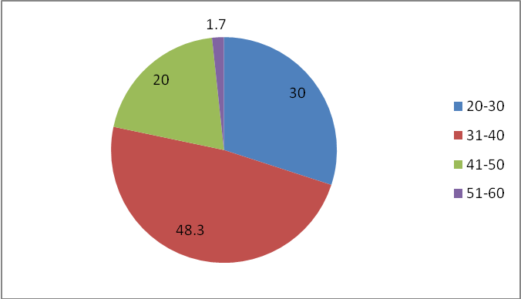
The above graph shows that 48.3% respondents belong to the age group 31-40 ,30% of the respondents belongs to the age group 20-30 ,20% of the respondents belongs to 41-50 and 1.7% of the respondent are belongs to the age group 51-60.It shows that when age of the respondent increases the participation is decreasing.
Gender
All the respondents are female mainly because of fewer participation of male in this field.So the researcher didn’t get any male respondent.
Marital status
78% of the repsondents are married and 18.3% are single and 1.7 % are seperated and 1.7% are divorced.
4.2 Education qualification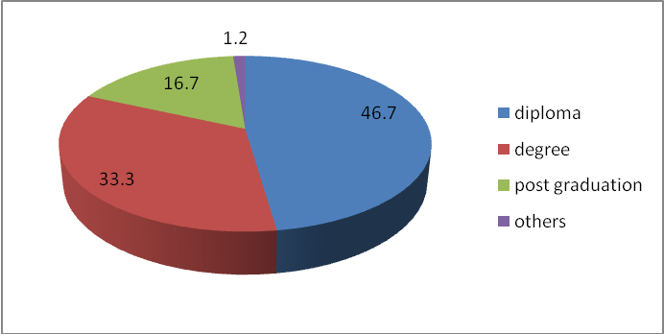

The above graph shows education qualification of the respondents 46.7% of the respondents have diploma in special education and 33.3% of the respondents have degree and 16.7% of the respondents have post graduation and it shows that all of the respondents have good education .

4.3 Community of the respondents

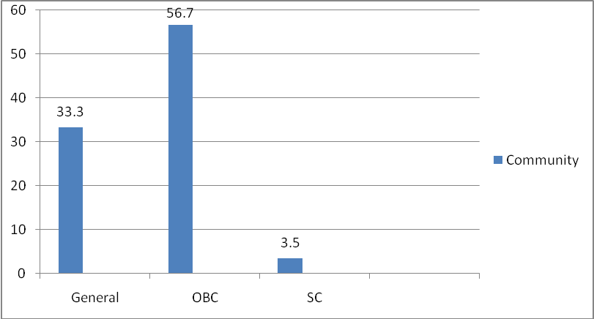
The above graph shows the community of the respondents.56.7%of the respondents belongs to OBC category and 33.3% in general category and 3.5% belongs to SC category and there is no participation in ST category.

4.4 Type of house
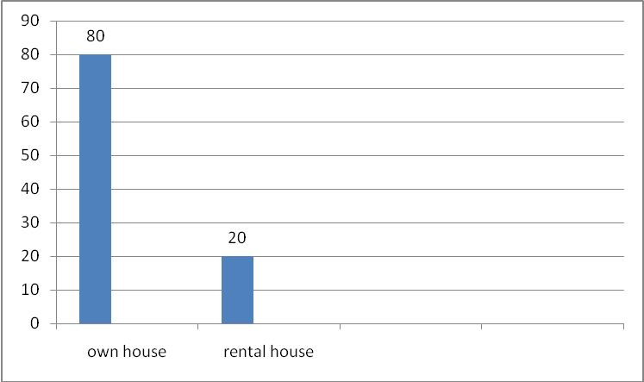

The above graph shows the type of house of the respondents 80% of the respondents have their own house and 20% are living in rental house .

Type of institution

All the respondents are belongs to unaided school because the participation of government in this field is very few and 53.3% are permanent employees and 46.7% are temporary employees and 76.7% do not have provident fund .
4.5 Total income of the respondents per month

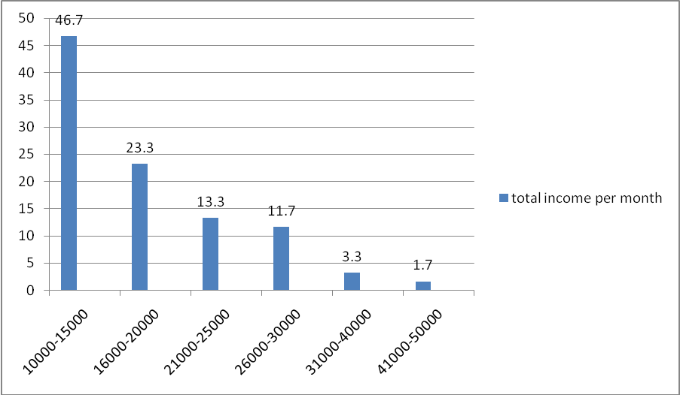

The above graph shows total income per month of the respondents.46.7%of the respondents have income in between 10000 to 15000 ,23.3% of the respondents have income in between 16000-20000,13.3% of the respondents have income in between 21000-25000,11.7% respondents have income in between 26000-30000and 3.3% of the respondents have income in between 31000-40000 and 1.5% have in between 41000-50000.So the mean income of the participants is 18863.

4.6 Years of experience
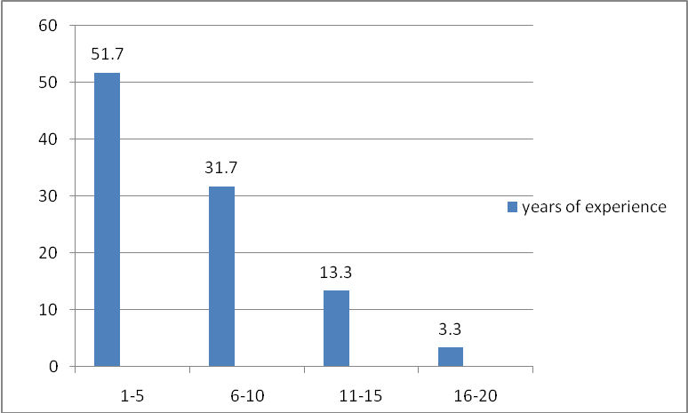
The above graph shows years of experience of the respondents .51.7 % of the respondents have 1-5 years of experience,31.7% have experience in between 6-10 years ,13.3% have experience in between 11-15 years and 3.3% of the respondents have 16-20.it shows that when years of experiences increases the participation is decreasing .
4.7 Salary of the respondents
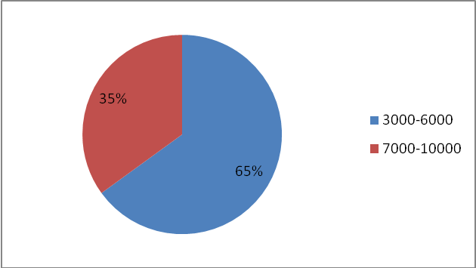

The above graph represent the salary of the respondents .65% of the respondents are getting salary in between 3000-6000 and 35% of the respondents have in between 7000-10000.it shows that the salary is very low.
4.8 Financial liabilities

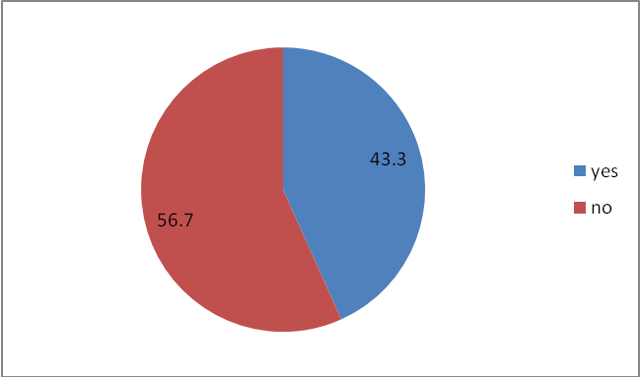
The above graph shows the financial labilities of the respondents.43.3% of the respondents have financial liabilities and they are not able to compensate it with their salary.
WORKING CONDITION
4.9 Working hours
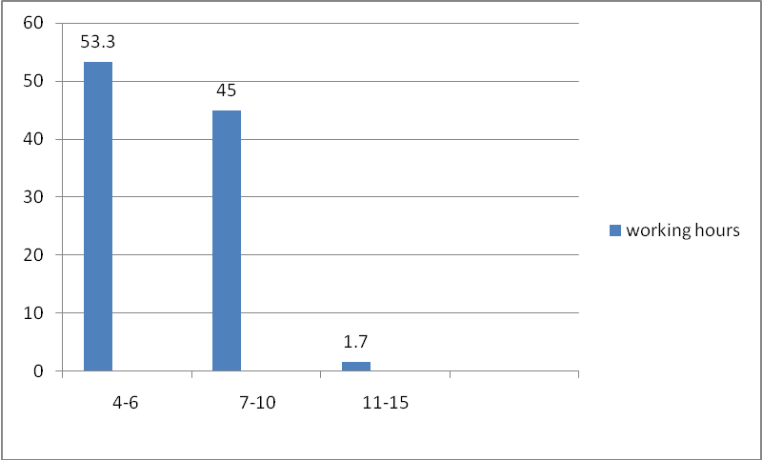
The above graph shows the working hours of the respondents .53.3% of the respondents are working in between 4-6 hours .45% of the respondents have 7-10 hours and 1.7% have 11-15 hours.

Help from aayas
All the respondents have help from aayas and 75% of the respondents have work relief or work reduction through the help from aayas

4.10 Class size

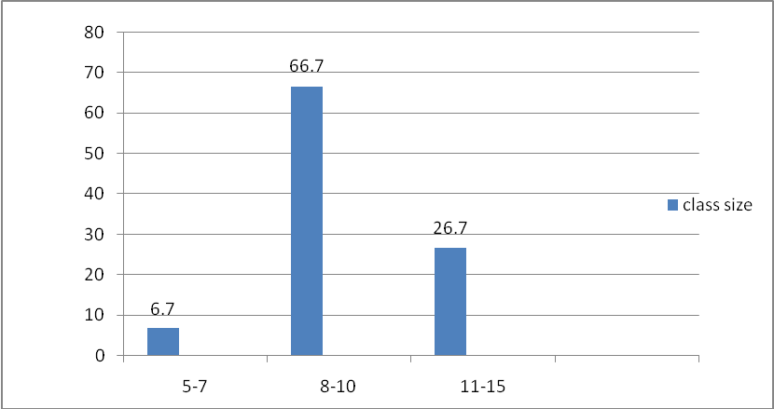

The above graph shows class size of the respondents .66.7% of the respondents have 8-10 students and 26.7% have students in between 11-15 and 6.7 % have 5-7 students.when the number of students increases it is very difficulty to handle ,especially they are differently abled children so they want more care and attention.The standard student teacher ratio is 1:8.

Teaching aid
All the respondent have teaching aid and 80% respondents are getting teaching aid provided by management and 20% are self preparation by the respondents.

4.11 Infrastructure facilities

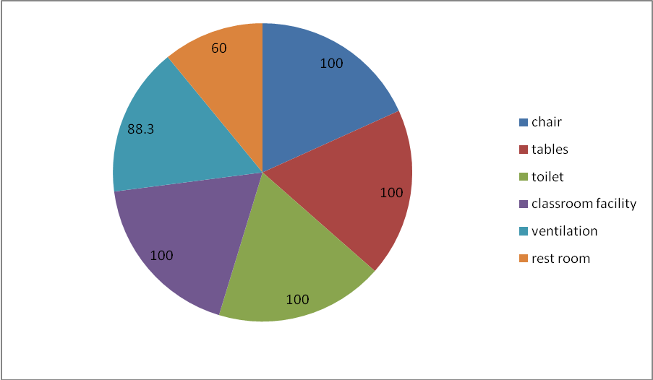
The above graph represent the availability of infrastructure facilities for the respondents.All of the respondents are getting infrastructure facilities like chair, tables toilet, classroom and 88.3% of the respondents have ventilation facility and 60% of the respondents have restroom facility
4.12 Injuries from students
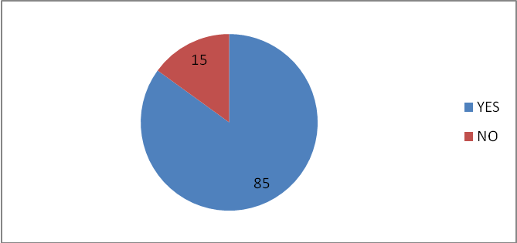
The above graph shows that injuries faced by the respondents .85% of the respondents are faced injuries from students like biting,beating etc and all the institutions have first aid facilities .15% getting injuries regularly and 45% sometimes and 25% rarely .

4.13 Leave conditions for the respondents
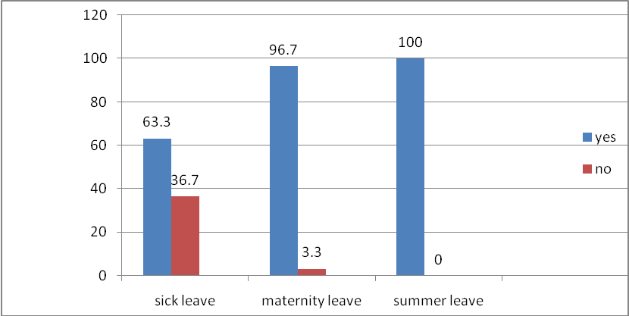
The above graph shows the leaves available for the respondents.63.3% of the respondents have sick leave and 36.75 do not have sick leave.96.7% have maternity leave and 3.3 % do not have maternity leave and all of the respondents have summer leave.
4.14 Challenges during teaching
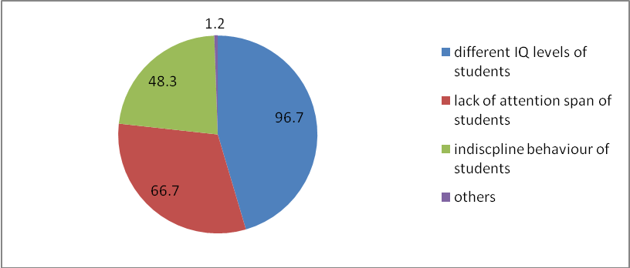
The above graph shows the challenges during teaching .96.7% of the respondents have difficulty in teaching due to different IQ levels of the students and 66.7% of the respondents have difficulty due to lack of attention span of the students and 48.3 % of the respondents also have difficulty due to indiscipline behaviour of the students.

4.15 Thought for quitting job
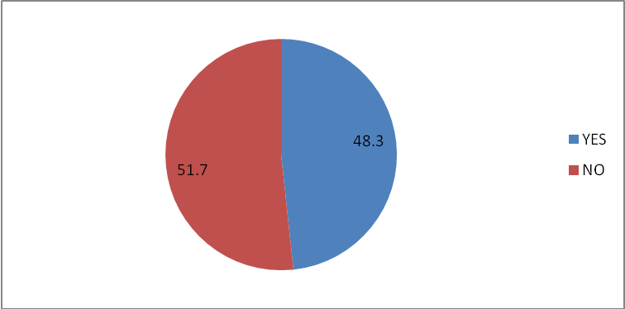
The above graph shows that respondents thought for leaving profession.48.3% of the respondents thought for leaving profession due to lower salary because most of the special schools are run by management and they do not have enough fund for paying higher salary for teachers and the fund by government also very limited., pressure from parents ,travelling expenses etc.
SUPPORT SYSTEM
4.16 Support from family
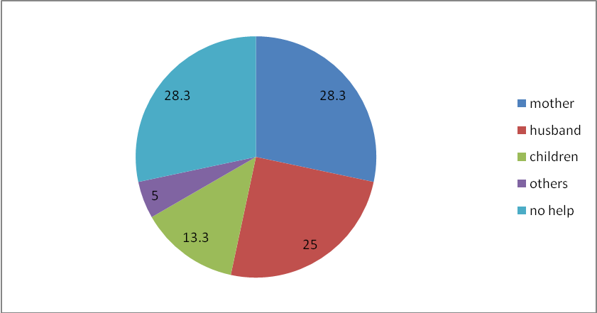
The above graph shows the support of family of the respondents.28.3 % of the respondents have support from mother for doing daily chores at home and 25% from husband and 13.3% from children and 28.3% do not have support from anybody in the family..
4.17 Support from student parents

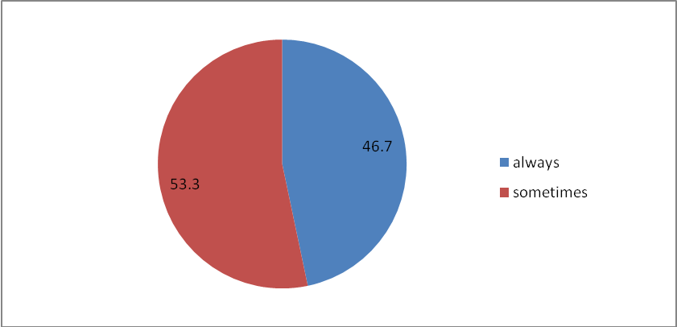

The above graph shows the support of parents of students for respondents .53.3% of the respondents are sometimes getting support from the parents of students and 46.7% of the respondents have always getting support from parents of students .
4.18 Support during work related problems
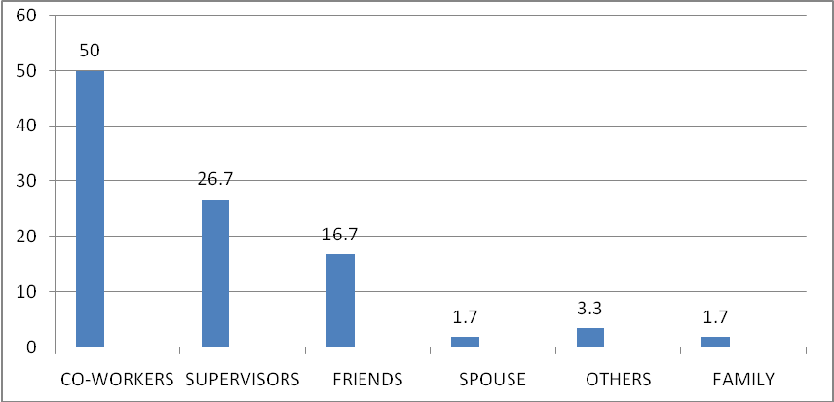
The above graph shows support during work related problems of the respondents.50% of the respondents getting support from co-workers when they face work related problems and 26.7 from supervisors and 16.7 % from friends and 1.7% from spouse and 3.3% from others and 1.7 % from family .
4.19 source of Appreciate and encourage

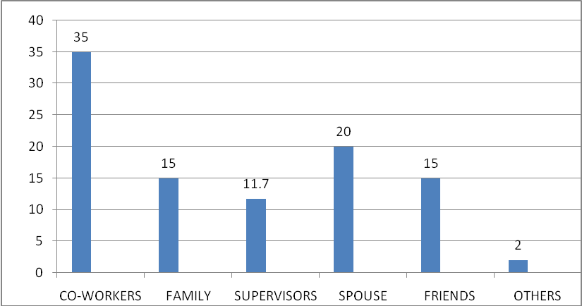
The above graph shows the support to appreciate and encourage the work of the respondents .35% of the respondents have support to appreciate and encourage by co-workers and 30% from spouse and 15% from both family and friends and 11.7 % from supervisors for their work.
4.20 Support when personal sharing problems
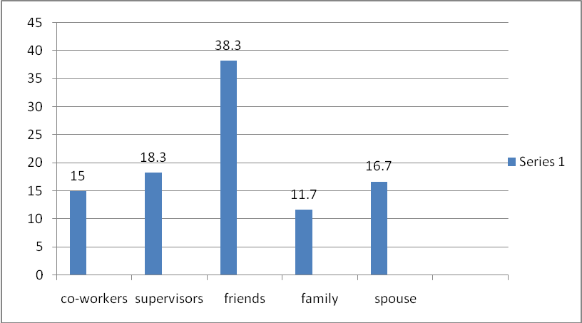
The above graph shows the support and security when sharing problems of the respondents. 38.3 % of the respondents feel secure when they share their problems to friends and 18.3% to supervisors and 16.7 % to spouse and 15% to co-workers and 11.7% to family.
4.21 Guidance and advices for their work
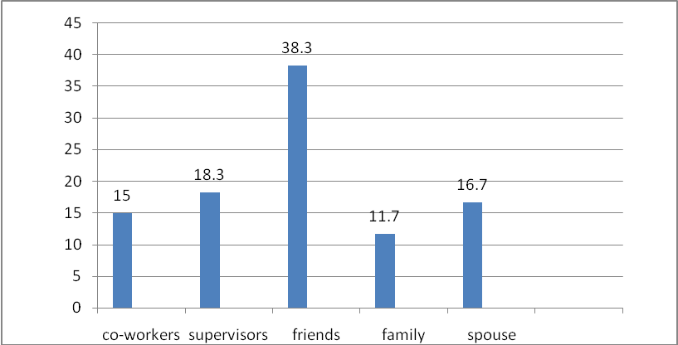
The above graph shows support for respondents when they need guidance and advices for their woek.38.3% of the respondents have support as guidance and advices from friends and 18.3% from supervisors and 16.7 % from spouse and 15% from co-workers and 11.7% from family.
STRESS
4.22 Stress due to work related responsibility
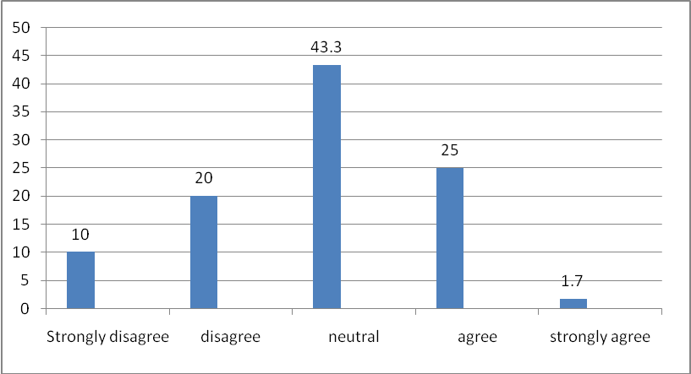
Above graph shows that 26.7% respondents agree that they have stress due to more responsibility of their job such as paper work ,teaching ,taking care of children etc and 43.3% respondents has neither higher nor lower stress due to the higher responsibility and 30% do not have such stress.
4.23 Conflicting demands from students ,parents administrators and teachers
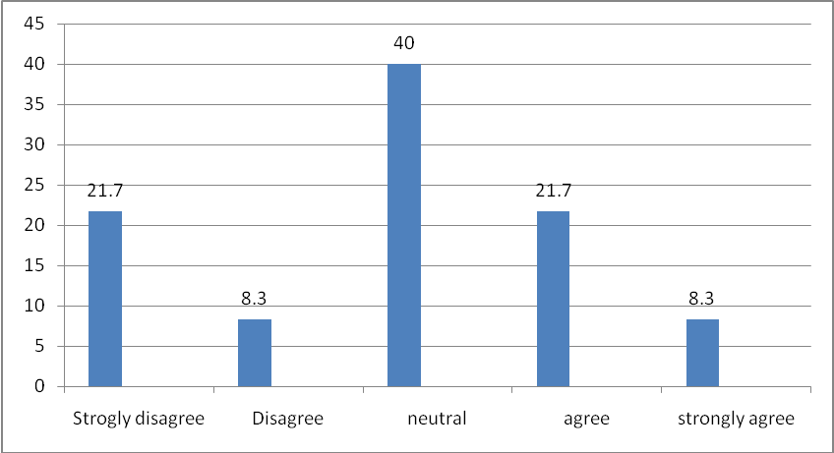
Above graph shows that 30% of the respondents agree that they have stress due to conflicting demands from students ,parents,administrators and teachers for fulfilling their needs and 40% respondents are neither agree nor disagree that they have stress due to conficting demands.
4.24 Stress due to work with insufficient resources
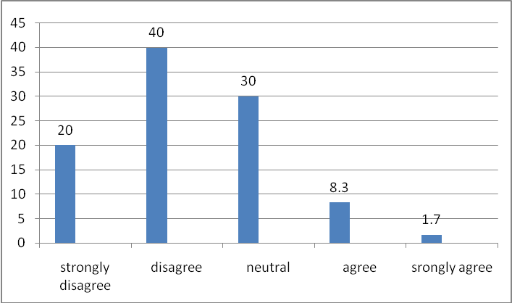
Above graph shows that 30% of respondents have stress due to insufficient resources such as for extra curricular activities for sports and arts and such other programs 60% of the respondent do not have such stress .government role of providing this resources are very limited and the sources is mainly through management .
4.25 Administrative head ask opinion
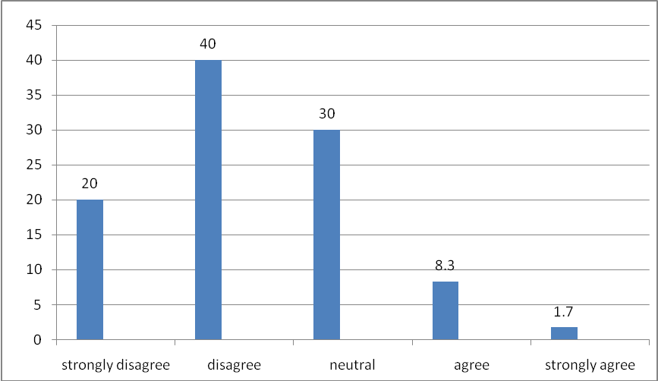
Above graph shows that 60% disagree that administrative head ask their opinion on decision that directly affect the respondents ,30% neither agree nor disagree that and 10% of the respondents agree that administrative head ask their opinion
4.26 Routine and boring
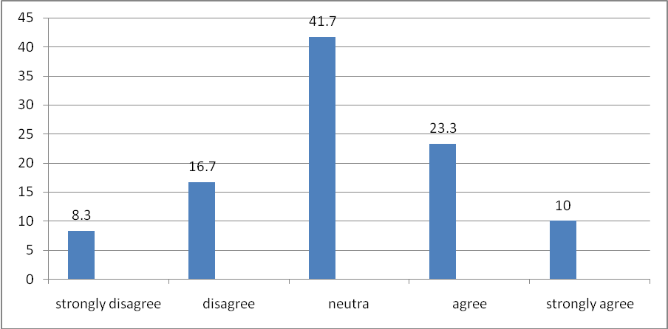
Above graph shows that 33.3% respondents agree that they have stress due to work become too routine and boring because all the day they are doing same work and also give same instructions each day and 41.7% are neither agree nor disagree that they have stress due to job become routine 25% do not have such stress.
4.27 Stress due to school activities outside normal working hours
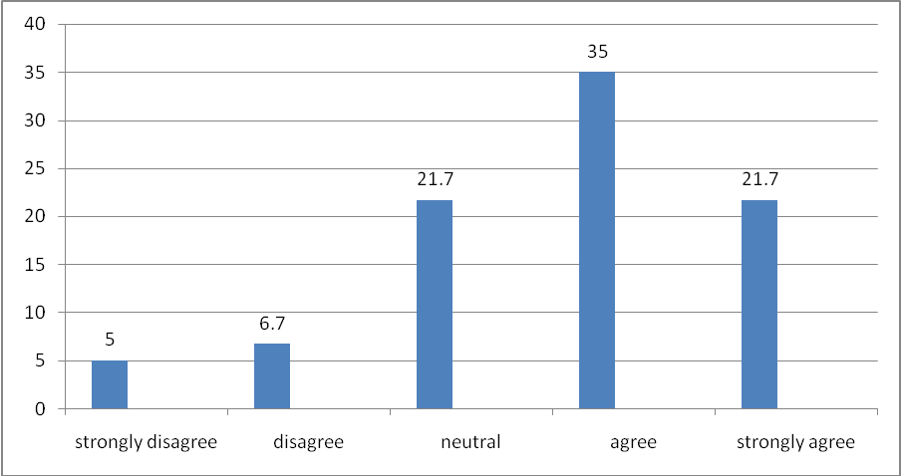
Above graph shows that 56.7% of the respondents agree that they have stress due to school activities outside normal working hours and only 11.7 % are do not agree that they have any stress due excess work and 21.7% neither agree nor disagree that they have stress due to this outside normal working hours.
4.29 Extra effort to instruct students.
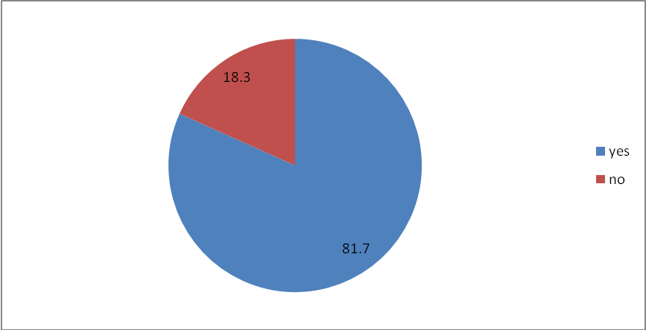
Above graph shows that 81.7% of the respondents have extra effort due to give instructions repeatedly to the students and 18.3% do not have any extra effort .Among these 81.7% it will leads to health problems such as headache,throat problems etc by 65% of the respondents.

4.28 Stress due to address the needs of fellow faculty

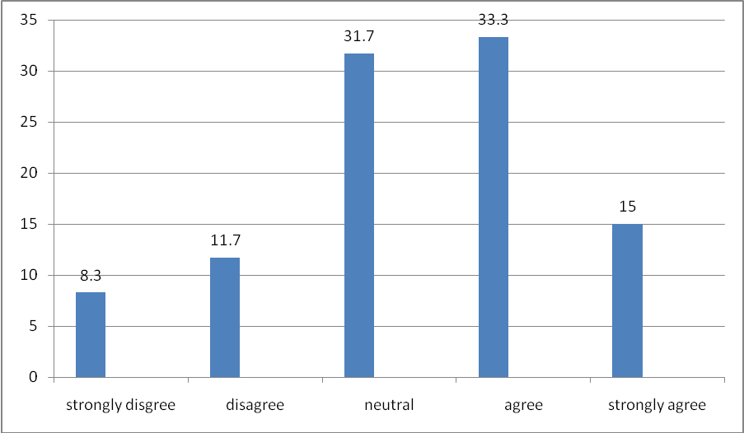

Above graph shows that 58.3% respondents agree that they have stress due to meet needs of fellow faculty such as they have the responsibility to take care other class student also when they have any other need or when other faculty take leave

CHAPTER 5
FINDINGS , CONCLUSION AND SUGGESTIONS

FINDINGS
Introduction
Findings were based on the objectives of the study. The major findings of the study are provided in a descriptive manner in the following sequence that begins with description of socio-demographic profile, working condition of the respondents ,support system by administrative authorities ,co-workers, parents and to know their stress level among the sample population.
Socio demographic profile
• Age wise : 48% of respondents are age in between 31-40 and the participation is getting lower when participation get aged.
• Gender : All the respondents are female due to lesser participation of male in this field.
• Education qualification: All the respondents have good education qualification such as diploma, degree and post graduation in the respective field.
• Type of house : 80% of the respondents have their own house and 20% have rental house .
• Total income of family : the total income of a family per month minimum is 3000 and maximum is 50000 and the mean income is 18863.
• Type of school: All the respondents belong to unaided school. The government undertakings is lesser in this field .53.3% are peranent employees and 46.7% are temporary employees and 76% do not have provided fund.
• Experience : 51% respondents have experiences in between 1-5 and when people get more experienced the participation is decreasing.
• Salary : 61% of the respondents have the salary in between 3000-6000 and there is no significant changes in their salary even if they are highly experienced or not. The minimum salary is 3000 and maximum salary is 10000 and the mean salary is 6366.
• satisfaction about salary : All the respondents are not satisfied with their salary.
• Financial liabilities : 43% of the respondents have financial liabilities and they are not able to compensate it with their salary .

Working condition
• Working hours : 53% of the respondents are working in between 4-6 and 45%of the respondents are working beyond their working hours.
• Class size : 25% of the respondents have the difficulty for managing students due to large class size in between 11-15.
•Help from aayas : all of the respondents have help from aayas and 75% have work reduction by the help of aayas
• Teaching aid : 98% of the respondents get teaching aid and it is mainly provided by management and self preparation.
• Infrastructure facility : All of the respondents get adequate infrastructure facilities .
• Injuries from student : 85% o the respondents have to face misbehave and injuries from student like biting, beating , spiting etc.
• Leave conditions : 98% of the respondents have maternity leave and summer leave and 28% do not have sick leave.
• Challenges during teaching : 96% of the respondents have challenges during teaching such as different IQ levels of students,lack of attention span of students and indiscipline behaviour of students.
• Thought for leaving profession : 48% of the respondents thought for leaving this profession due to lower salary, pressure from parents of students, travelling expense etc.
Support system
• Family support : 71% of the respondents have good support from their family such as from mother ,husband and children also helps to do daily chores at home.
• Support from parents of students : 81% of the respondents have good support from the parents of students.
• Support from co –workers,administration : all the respondents have good support from co-workers ,supervisors ,friends, spouse, family when they have work related problems and appreciate and encourage their work and also give guidance and advices when they need.

Stress
• Extra work : 65% of the respondents have stress due to extra work beyond their working time .
• Conflicting demand : 64% of the respondents have stress due to conflicting demand from parents of students,students and administrators.
• Routine work : 74% of the respondents have stress due to do similar work again and again each day .
• Need of fellow faculty : 79% of the respondents have stress due to when they meet the need of another faculty.
•Extra effort : 81% of the respondents are putting extra effort to instruct students which create issues like headache , over tension, throat pain etc.

CONCLUSION

Special education is the practice of educating students in a way that addresses their individual differences and needs. Ideally, this process involves the individually planned and systematically monitored arrangement of teaching procedures, adapted equipment and materials, and accessible settings. These interventions are designed to help individuals with special needs achieve a higher level of personal self-sufficiency and success in school and in their community which may not be available if the student were only given access to a typical classroom education. The early origins of special education in India started with christain missionaries and non governmental agencies which stressed a charity model of serving population such as the visually ,hearing and cognitively impaired . However after independence from Great Britain in 1947,the Indian government became more involved in providing educational ,rehabilitation and social services. Special education teachers work with students who have a wide range of learning, mental, emotional, and physical disabilities. They adapt general education lessons and teach various subjects, such as reading, writing, and math, to students with mild and moderate disabilities.
The study findings show that all respondents are female mainly because of the fewer participation of male in this field and all the respondents belongs to unaided school and their salary was very low and they are not satisfied with their salary and also have the difficulty to manage their life .Most of the respondents have proper infrastructure facilities . Special school teachers frequently face different misbehave and injuries from students .Due to the lower salary and low support from student parents ,travelling expenses etc leads half of the respondents thought for leaving job. They have good support from their family ,co-workers ,administrators etc. They are also facing stress due to more responsibility of their job, to meet the needs of fellow faculty ,working beyond the normal working hours ,work become too routine and boring etc leads to stress and burnout among special school teachers .The role of government in this field is very limited .

SUGGESTIONS
Based on the result that the study proposes the following suggestions to address the issues faced by special school teachers .
• The study suggested it will be better if the unaided school can be accredited as to aided school.
• The study suggested that government should provide teaching aid and resources for organising extra curricular activities .
• Make workshops to aware student parents about the need to support teachers.
• Increase the reward patterns for the financial assistance of special school teachers.
• The salary given to them is not sufficient to meet their needs even though their job demands hard work .

BIBLIOGRAPHY

• Billingsley BS 2004. Special education teacher retention and attrition: a critical analysis of the research literature. The Journal of Special education, 38:39-55.
• Department of Education, Education White Paper 6, 2001. Special Needs Education: Building an Inclusive Education and Training System. Pretoria.
• Louise Strydom, Nico Nortjé, Roelf Beukes, Karel Esterhuyse
and Jeanne van der Westhuizen 2012.Job satisfaction among teachers at special needs schools.
• Giichi Masawa, Masao Seo and Shinro Kusanagi 1993 . Teacher Education to Enhance the Quality of Special Education in Japan.peabody journal of education 68(4),47-59.
• Paul Croll and Diana Moses 2000 . Continuity and Change in Special School Provision: Some Perspectives on Local Education Authority Policy-Making.British educational research journal 26(2),177-190.
• Deborah L. Voltz 2001. Preparing General Education Teachers for Inclusive Settings: The Role of Special Education Teachers in the Professional Development School Context . Learning disability quarterly 24(4),288-296.
• CROLL, P. & MOSES, D. (1998a) Pragmatism, ideology and educational change: the case educational needs, British Journal of Educational Studies,46,PP.11-25.
•SPECIAL EDUCATIONAL NEEDS TRIBUNAL (1995) Annual Report 94-95 (London, Special Needs Tribunal).
• SWANN, W. (1985) Is the integration of children with special needs happening? Oxford Education, 11, pp. 3-18.
•Kaff MS 2004. Multitasking is multitaxing : Why special teachers are leaving the field. Preventing School Failure, 48:10-17.
•Bolowane A 2005. Teachers want armed guards at schools. The Mercury, 15 March.
Botha RJ 2002. Outcomes-based education and educational reform in South Africa. International Journal of Leadership in Education, 5:361-371.
•Castro AJ, Kelly J & Shih M 2010. Resilience strategies for new teachers in high-need areas. Teaching and Teacher Education, 26:622-629.

APPENDIX
QUESTIONNARE
Title : Occupational challenges faced by special school teachers – a study in Trivandrum district
General Instruction :
It is assured that the data provided by you shall be used only for academic purpose
Please fill out the form with the facts to the best of your knowledge.
- Age :
- Gender : male female
- Marital status : single married separated divorced
- Education qualification

DIPLOMA
DEGREE
POST GRADUATION
OTHERS ,Specify
- Community : General OBC SC ST
- Type of house
Own house Rental
- Family details

PARTICULARS
Total no of members
Employers
Students
Oldage people (more than 60 years)
Total income of the family

- Professional life
SL.NO. | NAME OF THE INSTITUTION | NO.OF YEARS OF EXPERIENCE | SALARY
1
2
3
4
5

- Type of the present institution

Government aided unaided
- Are you a permanent employee of this institution?
Yes No
- Do your institution provide PF(provident fund)?
Yes No
- Do you have any financial liabilities?
Yes No
- If yes can you able to compensate with your salary?
Yes No
- How do you utilize the major part of your salary?

*To run family
*to educate children
*for savings
* paying debts
*others, specify
15. How many hours do you work per day ?

- Do you work beyond your working hours ?
Yes No
- Do you get any help from aayas?
Yes No
- If yes, is it reduce your work ?
Yes No
- What is your class size ?

- Do you get proper teaching aid?
Yes no
- If yes, who provide you ?
Management govt others , specify
- Did your institution has adequate infrastructure facilities listed below (if yes put tick ?
Tables
Chair
Blackboard
Drinking facilities
Toilet facilities
Class room facilities
Ventilation facilities
Rest room
- Do you face any misbehave or injuries from students?
Yes No
- If yes what kind of injury you are facing?

- If yes, what is the frequency of getting injury?
Regularly Sometimes Rarely
- Do you get any kind of first aid facilities from the institution?
Yes No
- Do you have structured curriculum for teaching students?
Yes No
- Do you ever face any harassment from working environment?
Yes No
- Do you get proper resources for organizing extra curricular activities ?
Yes No
- If no do you get any difficulties in extra curricular activities ?
Yes No
- Do you have sick leave ?
Yes No
- Do you have maternity leave?
Yes No
- Do you have summer leave?
Yes No
- What are the challenges you face during teaching?

*Different IQ levels of students
* lack of attention span of students
* Indiscipline behaviour of students
* others ,specify

- Do you get enough time to spend with your family?
Yes No
- Is there anybody to help you with daily chores at home?
Yes No
- If yes, specify
Mother husband servant children others
- Do you get any kind of pressure from parents of students ?
Yes No
- Are you satisfied with the support from parents of students ?
Always sometimes Never
- Are you getting help from co workers when you need?
Yes No
- Whom do you consult when you face work related problems ?
Co workers supervisors friends spouse others ,specify
- Which category appreciate and encourage you for your work?
Co workers family supervisors spouse friends others,specify

- With whom you feel secure when you share your problem?
Co workers supervisors friends family spouse others ,specify
- Whom would you depend for guidance and advices when you need?
Co workers supervisors friends spouse others ,specify
1 2 3 4 5
( Strongly disagree Dis agree Neutral Agree Strongly agree )

46. I find that i have extra work beyond what the demands of my job are 1 2 3 4 5

47. I am given too much responsibility without adequate authority to carry it out 1 2 3 4 5

48.I receive conflicting demands from two or more people or groups in the 1 2 3 4 5
school setting

49.I have a hard time satisfying the conflicting demands of students,parents 1 2 3 4 5 Administrators & teachers
50.I am given school-related duties without adequate resources and materials 1 2 3 4 5 carry out them out
51.My administrative head ask my opinion on decision that directly affect me 1 2 3 4 5

52.my administrative head brings me together with other faculty in joint 1 2 3 4 5
meetings to make decisions and solve problems
53.There is a lot of stress just keeping up with the changing professional 1 2 3 4 5
standards.
54.Trying to keep my work from being too routine and boring puts a lot 1 2 3 4 5
of stress on me.

55.Having to participate in school activities outside of the normal working 1 2 3 4 5
hours is very stressful to me
56.I find that trying to be attentive to the problems and needs of fellow 1 2 3 4 5
faculty is very stressful
57.I find that trying to be attentive to the problems and needs of fellow 1 2 3 4 5
faculty is very stressful
58.
 | YES | NO
Do you have to put extra effort to instruct students(like repeating instructions ?
If yes does it affect your health?
If yes ,specify

